**Suppose we have a csv file *students.csv* and its contents are:**

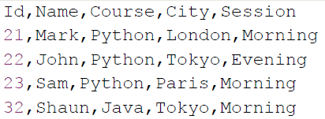+

We want to read all the rows of this csv file line by line and process each line at a time.

Also note that, here we don’t want to read all lines into a list of lists and then iterate over it, because that will not be an efficient solution for large csv file i.e. file with size in GBs.

We are looking for solutions where we read & process only one line at a time while iterating through all rows of csv, so that minimum memory is utilized.

Python has a csv module, which provides two different classes to read the contents of a csv file i.e. ***csv.reader***and ***csv.DictReader***.

With csv module’s reader class object we can iterate over the lines of a csv file as a list of values, where each value in the list is a cell value.

**Read csv file without header**

suppose we want to skip the header and iterate over the remaining rows of csv file.

**print(row)**

**Output:**

**Output:**

**Output:**









